**School Ranking Analysis.**

**Task to be performed:**

* Write a query to create a **students**table with appropriate data types for student id, student first name, student last name, class, and age where the student last name, student first name, and student id should be a **NOT NULL constraint**, and the student id should be in a **primary key**.

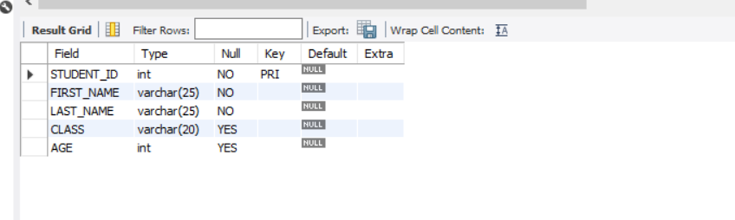

* Write a query to create a **marksheet** table that includes score, year, ranking, class, and student id.

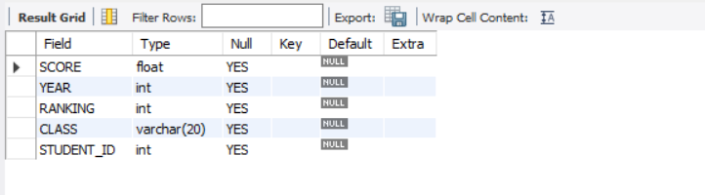

* Write a query to **insert** values in **students** and **marksheet** tables**.**

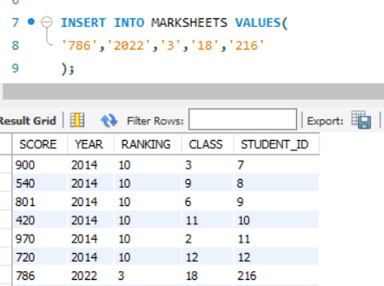

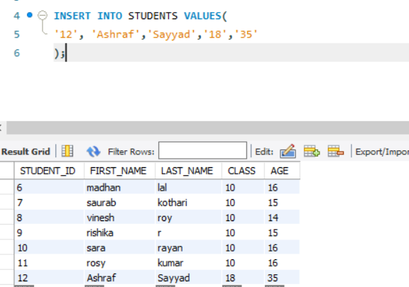

* Write a query to display student id and student first name from the student table if the **age is greater than or equal to 16** and the **student's last name is** **Kumar.**

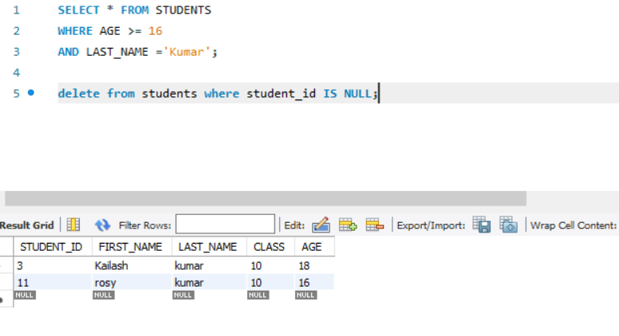

* Write a query to display all the details from the marksheet table **if the score is between 800 and 1000.**

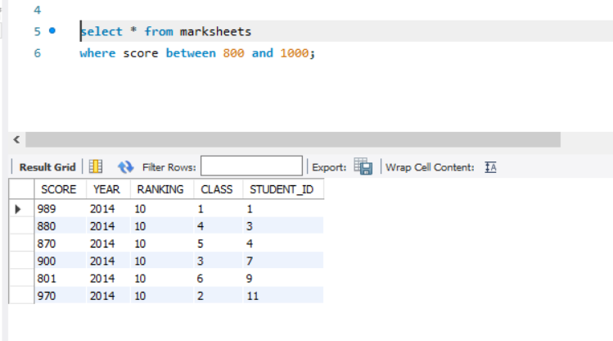

* Write a query to display the marksheet details from the marksheet table by **adding 5 to the score** and by naming the **column** as **new score**.

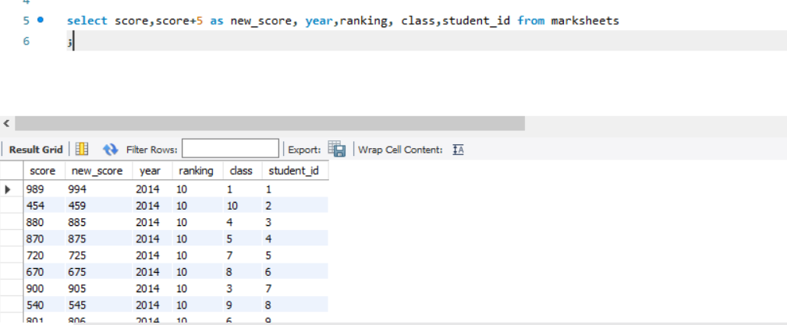

* Write a query to display the marksheet table in **descending order of the  score**.

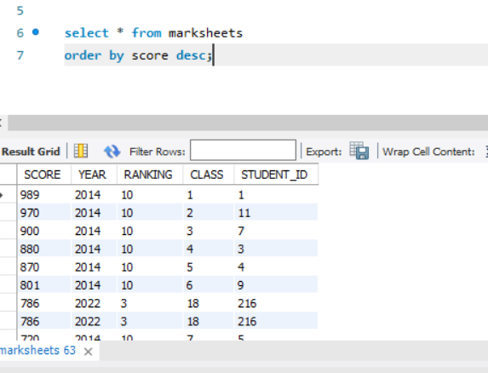

* Write a query to display details of the students whose **first name starts with a.**

